Jehloni Willis

Website type: Blog style gaming

Game: SMITE

Similar websites:

<https://smitesource.com/builds>

This website is similar to mine by showing the builds for each character updated and allows the user for easy access for gameplay

<https://www.smitefire.com/smite/blog>

This website is similar by covering god, abilities, items, and creates a community with creating a forum.

**Characteristics**

* Gods (There are over 100+ gods in the game to choose from that go into specific roles to fit your playstyle and game mode and shows rotation gods and base gods (free characters))
* Skins (This is a page that gives you character release dates, chest rolls, skin release dates, and community skins)
* Balance changes (This will show the update show details, show buffs/nerfs to each gods, map changes, item nerf/buffs, Quality of life changes, and bug fixes)
* Gem sales (This tells the user when Gem sale are avaliable
* Skin collabs (upcoming skin collabs featuring things outside of smite that are coming into the smite universe)
* Forum (This allows the community to communicate)
* Battle pass (Current and past battle passes that are available for purchase and inclusive additions even if bought individually)
* Twitch skins (This shows Monthly/Weekly Patch update twitch skins)
* Item changes (The changes made to items that are built in the smite game)
* Character release (New upcoming gods, release dates, and discussion of new concepts of gods)
* Fan made skins (This page represents favorite skins made by the community)

**Website purpose**

This gives the player an overview on the game changes. Sometimes it is a little difficult to keep up because they update the game very often and add deals that don't really get promoted as well and allows to open up a conversation on smite and what could change/improve.

**Analytics tools**

1. Google Analytics - [https://analytics.google.com/analytics/web/#/p315163886/reports/intelligenthom](https://analytics.google.com/analytics/web/#/p315163886/reports/intelligenthome)
   1. Google Analytics helps connect your website to it and make sense out of your metrics.
2. GTMetrix - <https://gtmetrix.com/>
   1. GT Metrix analyzes your website and and helps you make calculate decisions

**The Purpose of this website**

This website is to be able to show the player how to play the game, basics of learning game modes and give information of the character that are available, skins, balances to characters, map, and quality of life changes, deals/sales on skins and gems and brings a community together by creating a forum for people to communicate.

**Milestones**

* Sign in and sign out
* Create an account
* Email confirmation
* Make names under the characters an accessible link to page
* Add gameplay or youtube video links to how to use the character

**Primary goals**

* Make a page based on updates
* Make a page on gods
* Gems sale pages
* Make a forum
* Make a page for at least 5 or 10 characters

**Secondary Goals**

* Make the website as vibrant and lively as possible
* Add a description of positioning of character
* Add abilities to character page
* Seeing how many people use each god
* God win rate
* God lose rate

**Metrics**

* How many people create an account
* How many people comment on the forum
* How much engagement each page gets
* How many people click on the social media
* How many people come to the website on a daily basis

**Layout considerations**

* Horizontal in the middle of page to fit two thing in one
* Top full header on top of page
* Video on main page
* Gods page will have a split on the middle and have their build under the photo and abilities

I picked these ideas to bring in the viewer in and also allow my page to be creative but also very digestible

**Typography**

I want to have everything spaced out, organized and will make a range of 40-65 in text size and 28dp between each sentence.

**Font Type**

1. Play by Jonas Hecksher
2. Akshar by Tall Chai

I picked this font because it is any easy to look at font and give a familiarity to the original smite website

**Colors**

* 202C39 (Dark Blue)
* 545E31 (green)
* 6B8C9E (Light blue)
* F9C22E (Yellow)
* 858585 (Gray)

These colors resemble to Smite website/colors and I wanted to do these colors on the base page and when the colors for each god I want to change the colors for their pages as well.

**Accessibility Considerations**

* No effects the can trigger seizures
* Make keyboards accessible
* Make accessible for color blind people
* Simplistic design for fast navigation and easy accessibility

**Target Audience**

This website's targeted audience is mostly an age group between 14-30+ that love playing Multiplayer Online battle arenas and that are fascinated by mythology.

**Functionality**

* Allows people to connect on forum to show their art work, talk about balance updates and New and current gods
* Gives access to new player or current players that are confused about the game and explains new items and how to use characters

**Text and Image tools**

* Text
  + Lipsum- <https://www.lipsum.com/>
    - Lipsum is a text generator as placeholders
  + Google Fonts <https://fonts.google.com/>
    - Making the web more beautiful, fast, and open through great typography
  + Textise - <https://www.textise.net>
    - Strips all styles from webpages and leaves only text
  + Grammarly - <https://app.grammarly.com/>
    - Proofreading text
* Image
  + Burst - <https://burst.shopify.com/>
    - Image Library
  + Picsum - <https://picsum.photos/>
    - Image generator for placeholders
  + TinyPNG - https://tinypng.com/
    - Reduces the file size of images

**Sitemaps**

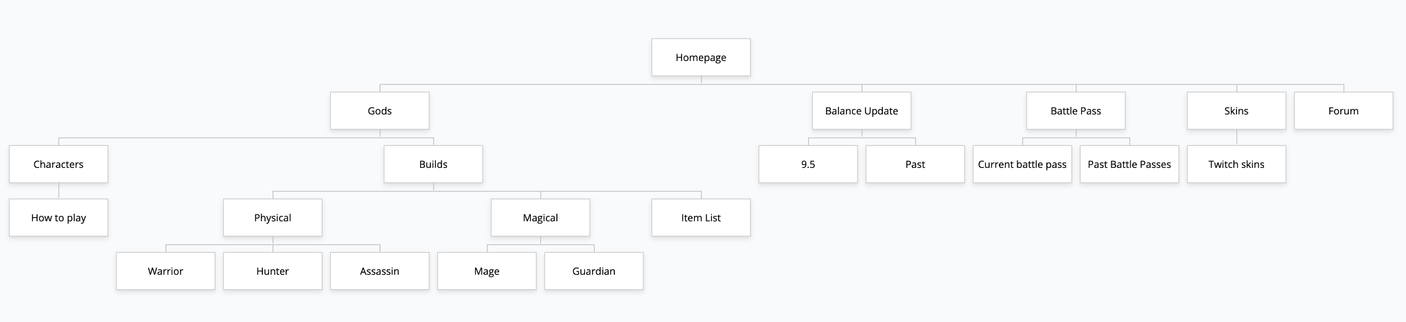

**Mockups**